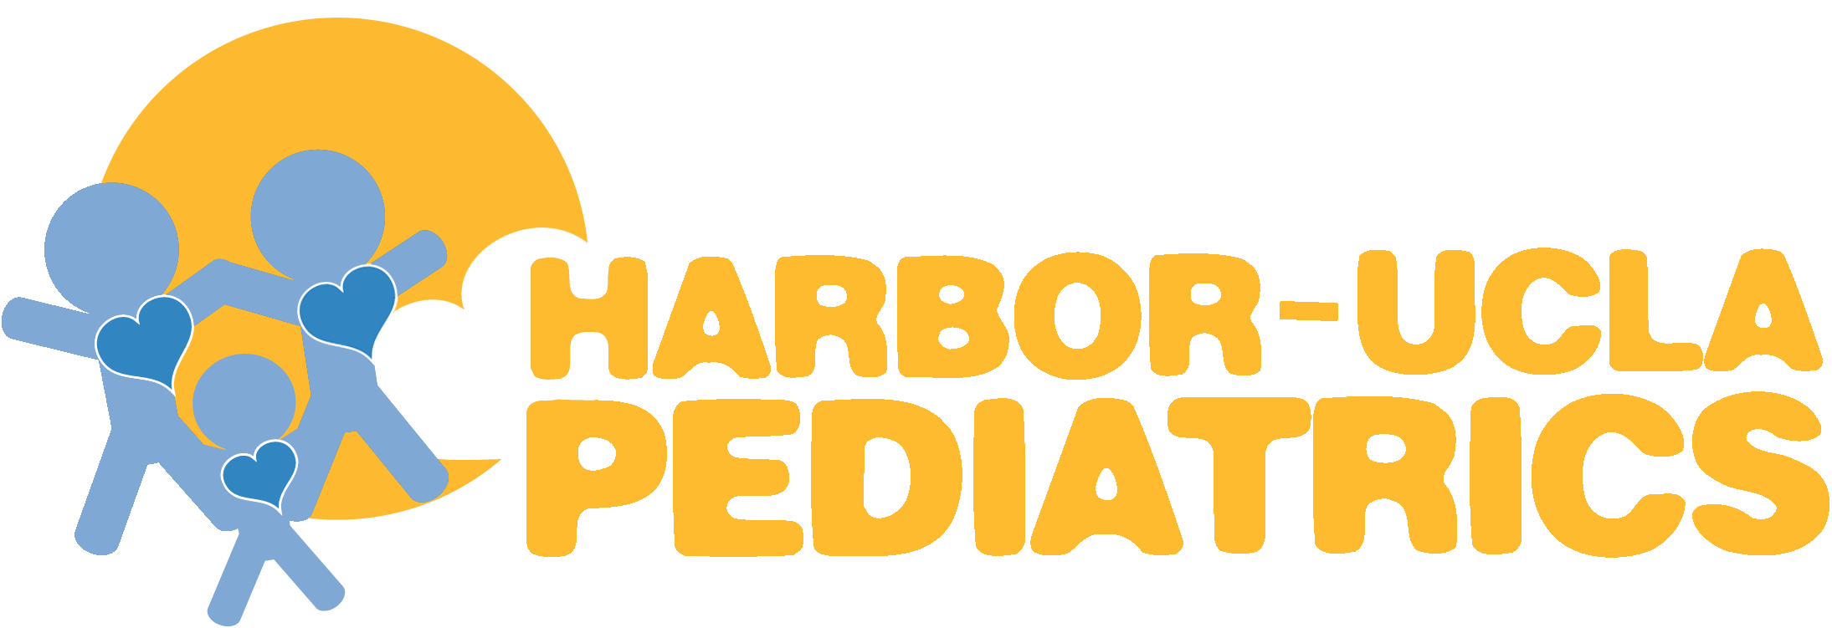
Division of Neonatology
The Division of Neonatology in the Department of Pediatrics at Harbor-UCLA Medical Center is seeking a neonatologist to join an established academic program. Harbor-UCLA Medical Center is a large academic health center and the only level II pediatric and level I adult trauma center located in the South Bay area of Los Angeles County. It serves 1.5 million people and has a 28-bed general pediatric unit, 8-bed PICU, Level III+ NICU, a pediatric emergency department, and the full range of pediatric and surgical subspecialties. Our mission encompasses medical education, clinical service, research, and advocacy.

The successful candidate will participate in clinical care in the NICU, teaching of medical students residents and fellows, research activities for the Department of Pediatrics, and serve on departmental committees. The ideal applicant should have a healthy interest in academic medicine.

Candidates must have an M.D. or D.O., have Board certification/eligibility in Pediatrics and Neonatology and be eligible for a California Medical License. The ability to foster collegiality and work collaboratively in a diverse environment is an expectation.

Academic rank and salary will be commensurate with experience. Faculty appointment is with the David Geffen School of Medicine at UCLA. Salary is enhanced by an attractive benefits package that includes professional liability coverage and a collegial, friendly, and SoCal relaxed work environment.

We value diversity and are committed to equal opportunity in employment. Further, loan repayment may be possible for the candidate.

Please send your CV to Lynne Smith, MD – Chair, Department of Pediatrics. Email: Lysmith@dhs.lacounty.gov

For more information,
visit our Website: http://www.harbor-ucla.org/pediatrics/
follow us on Facebook: https://www.facebook.com/HarborUCLAPeds/

